**Deploy AVL Fire M for HPC on a virtual machine**

This article briefly describes the steps for running [AVL Fire M](https://www.avl.com/fire-m) application on a virtual machine (VM) and HPC cluster that's deployed on Azure. It also presents the performance results of running Fire M on Azure Cyclecloud (HPC Cluster).

AVL FIRE M is the leading computational fluid dynamics (CFD) simulation package for the Internal Combustion Engine. In the new era of e-mobility, it has evolved into a comprehensive software tool offering solutions for a wide spectrum of applications; from fluid flow and thermal load in powertrain and vehicle components to vehicle aerodynamics, complex multi fluid / multiphase flows, encompassing also efficient and reliable solutions for electrification that can support virtual development and integration of e-driveline, battery and fuel cells. Designed to accurately simulate relevant physics and chemistry, it enables predictive simulations of fuel sprays, ignition, combustion and engine-out emissions as well as tailoring components of exhaust gas after treatment systems, but also the modelling of electrochemistry and thermal behavior of batteries and fuel cells.

The Key Benefits of AVL FIRE M

* Efficiently solving demanding flow problems in a variety of applications and industries
* Accurate simulation of heat transfer and thermal load problems
* Qualified and task-oriented software support along with application method development

**Architecture**

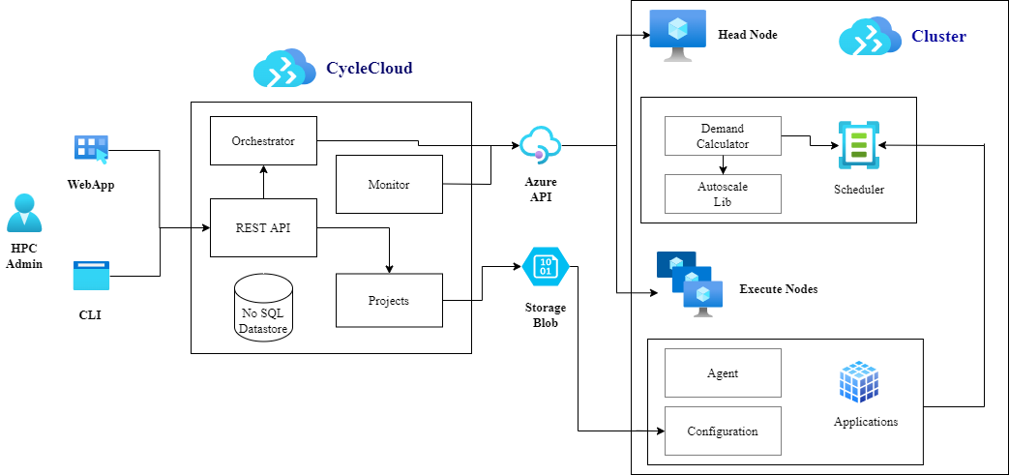

**Components**

* [Azure Virtual Machines](https://azure.microsoft.com/services/virtual-machines). Create Linux and Windows virtual machines in seconds.
* [Azure Virtual Network](https://azure.microsoft.com/services/virtual-network). Use Virtual Network to create your own private network infrastructure in the cloud.

**Install Fire M on a VM or HPC Cluster**

Before you install Fire M, you need to deploy and connect a VM or HPC Cluster.

For information about deploying the VM and installing the drivers, see one of these articles:

* [Run a Windows VM on Azure](https://docs.microsoft.com/en-us/azure/architecture/reference-architectures/n-tier/windows-vm)
* [Run a Linux VM on Azure](https://docs.microsoft.com/en-us/azure/architecture/reference-architectures/n-tier/linux-vm)

For information about deploying the Azure CycleCloud and HPC cluster, see below articles:

* [Install and configure Azure CycleCloud](https://docs.microsoft.com/en-us/learn/modules/azure-cyclecloud-high-performance-computing/4-exercise-install-configure/)
* [Create a HPC Cluster](https://docs.microsoft.com/en-us/learn/modules/azure-cyclecloud-high-performance-computing/5-exercise-create-cluster/)

To download Fire M products from the AVL portal:

1. Open the AVL portal in a web browser and sign in.
2. Select the **Self Service Portal** tab from the dropdown on the home page.
3. Select **Software Download**.
4. Select **AVL Simulation Suite <version>**
5. Select the download link for the latest version of Linux.
6. For license, contact through AST Hotline ServiceBase License ([ast_license@avl.com](mailto:ast_license@avl.com))

The application can alternatively be installed without downloading the large installation image by just running the installer executable (AVL SETUP.run).

See the [AVL Fire M website](https://www.avl.com/fire-m)for instructions for installing Fire M.

**Performance results of Fire M on an Azure VM**

Fire M was used to run steady state simulations.

DrivAer_BodyFitted: Open Cooling DrivAer Notchback is realistic test case relevant to automotive industry, accepted as the standard for automotive CFD correlation. For detailed description please refer to the SAE technical paper Hupertz, B., Chalupa, K., Krueger, L., Howard, K. et al., "On the Aerodynamics of the Notchback Open Cooling DrivAer: A Detailed Investigation of Wind Tunnel Data for Improved Correlation and Reference," ([SAE Int. J. Adv. & Curr. Prac. in Mobility 3(4):1726-1747,- 2021](https://doi.org/10.4271/2021-01-0958))

DrivAer_EmbeddedBody: Embedded body approach in FIRE M, which practically requires no conventional meshing, is used as an alternative to the standard (body-fitted) for the comparative assessment (Basara, B., Zunic, Z., Pavlovic, Z., Sampl, P. et al., "Performance Analysis of Immersed Boundary Method for Predicting External Car Aerodynamics," [SAE Technical Paper 2022-01-0889, 2022](https://doi.org/10.4271/2022-01-0889))

Please note that analysis (steady state RANS simulation) has been performed with decomposed mesh.

| **Model** | **Pressure Correcttion Equation** | **Pressure Boundary Values** | **Embedded Bodies** | **Flow Category** |
| --- | --- | --- | --- | --- |
| DrivAer_BodyFitted | Simple | Mirrored | No | Incompressible |
| DrivAer_EmbeddedBody | Simple | Extrapolated | Yes | Incompressible |

**Fire M 2022R1 performance results**

The DrivAer_BodyFitted & DrivAer_EmbeddedBody models are used for this performance evaluation.

**DrivAer_BodyFitted Model**

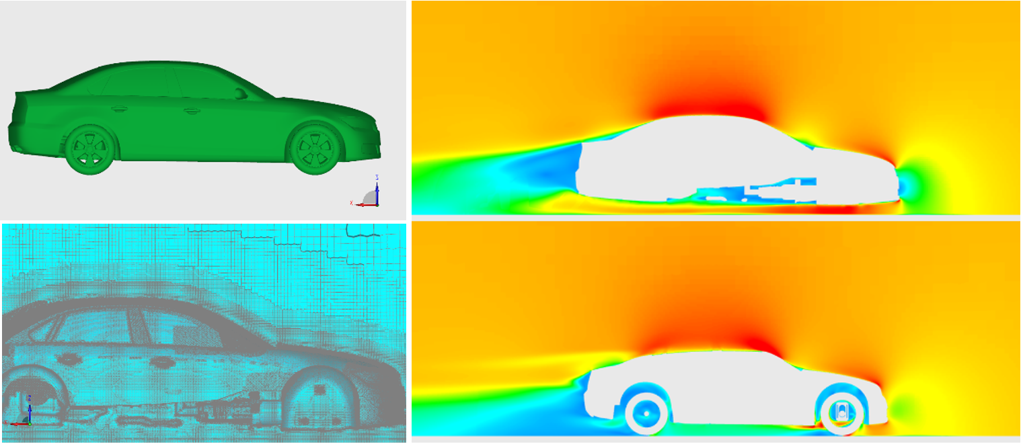

**DrivAer_EmbeddedBody Model**

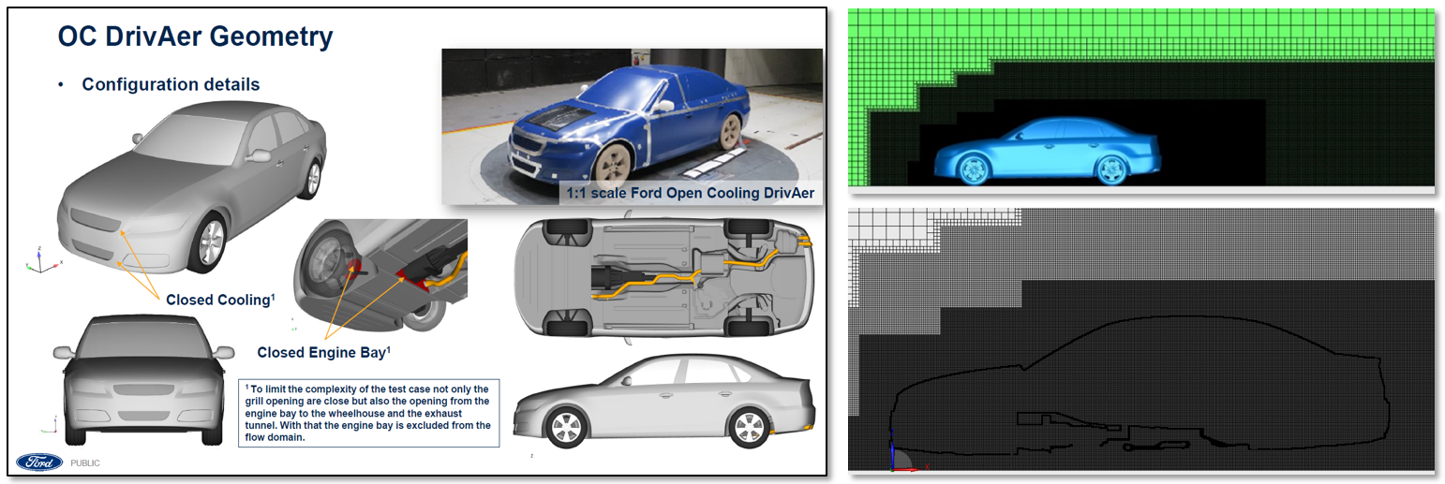

| **Model** | **Internal Cells** | **Run mode** | **Linear Solver** | **Iterations** |
| --- | --- | --- | --- | --- |
| DrivAer_BodyFitted | 128103525 | Steady State | Pressure GSTB | 300 |
| DrivAer_EmbeddedBody | 87365510 | Steady State | Pressure GSTB | 500 |

Steady state CFD analyses were performed on Azure Cycle Cloud multi-node setup with [HBv3 AMD EPYC™ 7V73X](https://docs.microsoft.com/en-us/azure/virtual-machines/hbv3-series) (Milan-X).

Single node result was considered as the baseline for comparing Multi-node CPU runs.

**Performance results for DrivAer_BodyFitted**

| **Number of Nodes** | **Number of CPU** | **Total run time in seconds** | **Relative Speedup** |
| --- | --- | --- | --- |
| 1 | 32 | 27098 | 1.00 |
| 2 | 64 | 13754 | 1.97 |
| 4 | 128 | 6757 | 4.01 |
| 8 | 256 | 3145 | 8.62 |
| 16 | 512 | 2076 | 13.06 |

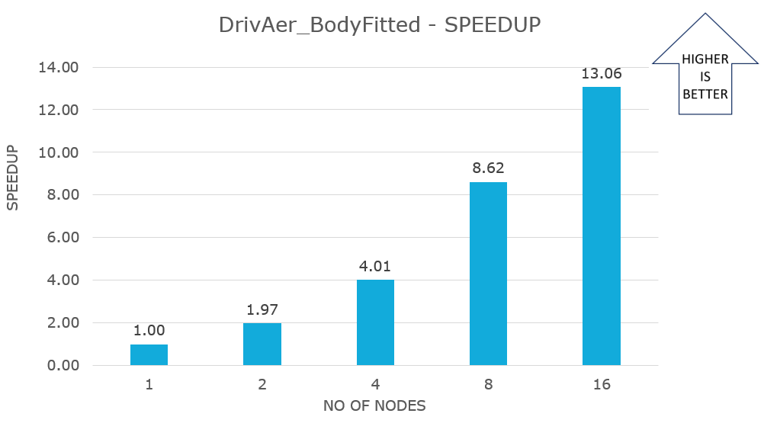

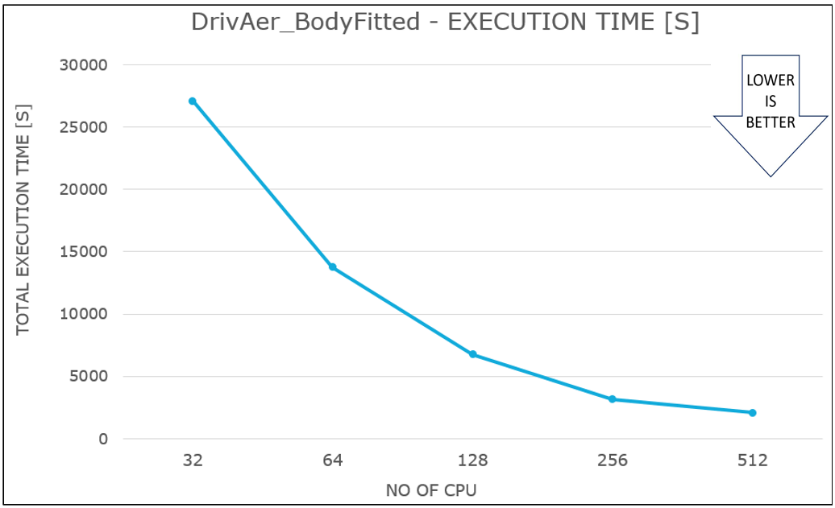

**Performance results for DrivAer_EmbeddedBody**

| **Number of Nodes** | **Number of CPU** | **Total run time in seconds** | **Relative Speedup** |
| --- | --- | --- | --- |
| 1 | 32 | 83387 | 1.00 |
| 2 | 64 | 41918 | 1.99 |
| 4 | 128 | 19851 | 4.20 |
| 8 | 256 | 9004 | 9.26 |
| 16 | 512 | 5872 | 14.20 |

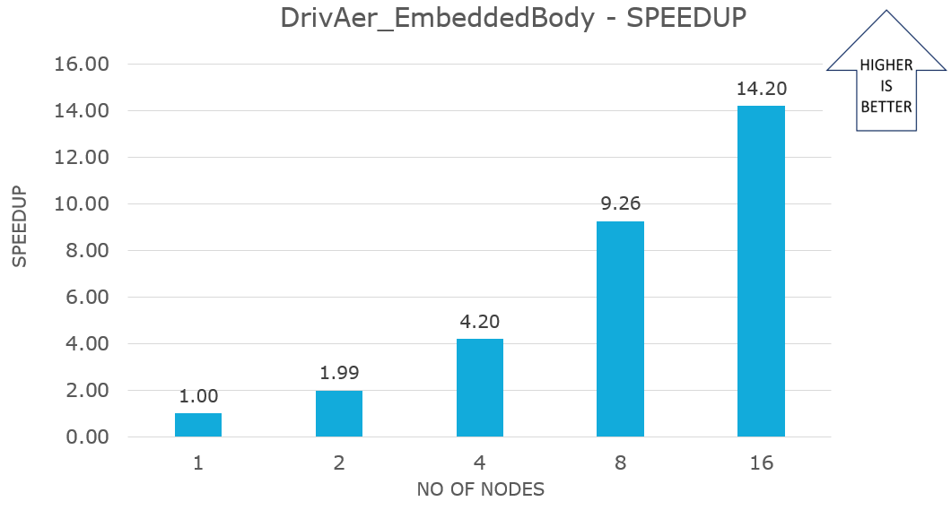

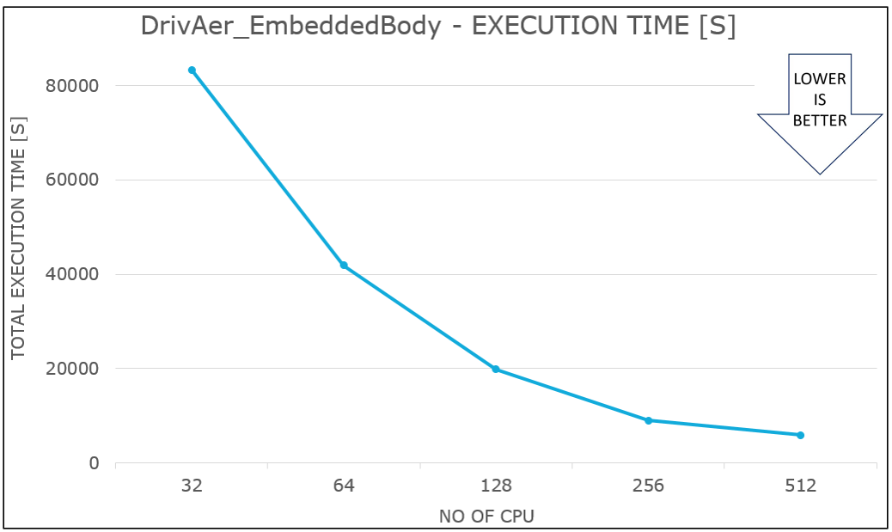

**Note**

To get a better speedup there has to be minimum of 20000 cells per CPU for single-phase incompressible flow simulation

**Pricing**

Only model running time (Total run time) is considered for these cost calculations. Application installation time isn't considered. The calculations are indicative. The actual numbers depend on the size of the model.

You can use the [Azure pricing calculator](https://azure.microsoft.com/pricing/calculator) to estimate costs for your configuration.

The following tables provide elapsed times in hours. To compute the total cost, multiply by the number of nodes and Azure VM hourly cost which you can find [here for Linux](https://azure.microsoft.com/pricing/details/virtual-machines/linux/#pricing).

**DrivAer_BodyFitted**

| **Number of Nodes** | **Total Run time in hours [1]** |
| --- | --- |
| 1 | 7.5 |
| 2 | 3.8 |
| 4 | 1.9 |
| 8 | 0.9 |
| 16 | 0.6 |

**DrivAer_EmbeddedBody**

| **Number of Nodes** | **Total Run time in hours [2]** |
| --- | --- |
| 1 | 23.2 |
| 2 | 11.6 |
| 4 | 5.5 |
| 8 | 2.5 |
| 16 | 1.6 |

**Additional notes about tests**

* Fire M was successfully tested on HBv3 AMD EPYC™ 7V73X (Milan-X) series on Azure Cycle Cloud multi-node setup.
* Both the models demonstrated good CPU acceleration in all multi-node setup.
* For this research, iterations are limited to a few, but in real-world circumstances, iterations can be more, and the decomposition time in total run time can become minimal, allowing performance to be increased even further.
* For small problems, we recommend to use the less number of CPUs to get a better performance.

**Contributors**

*This article is maintained by Microsoft. It was originally written by the following contributors.*

Principal authors:

* [Hari Bagudu](https://www.linkedin.com/in/hari-bagudu-88732a19) | Senior Manager
* [Gauhar Junnarkar](https://www.linkedin.com/in/gauharjunnarkar) | Principal Program Manager
* [Vivi Richard](https://www.linkedin.com/in/vivi-richard) | HPC Performance Engineer

Other contributors:

* [Mick Alberts](https://www.linkedin.com/in/mick-alberts-a24a1414) | Technical Writer
* [Guy Bursell](https://www.linkedin.com/in/guybursell) | Director Business Strategy
* [Sachin Rastogi](https://www.linkedin.com/in/sachin-rastogi-907a3b5) | Manager

*To see non-public LinkedIn profiles, sign in to LinkedIn.*

1. The total run time presented above is for 300 iterations only. Please note that the analysis time for fully converged solution can differ
2. The total run time presented above is for 500 iterations only. Please note that the analysis time for fully converged solution can differ